**Topic:DOCKER**

**1.Create your image with dockerfile.**

**2.Build and deploy your application in the Docker.**

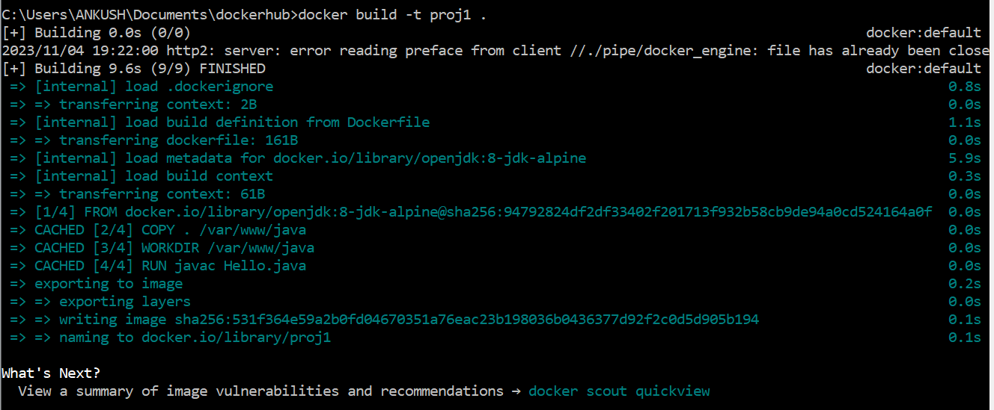

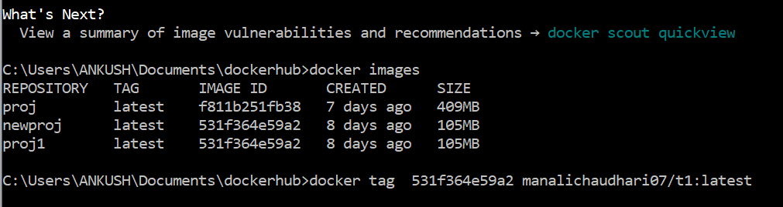

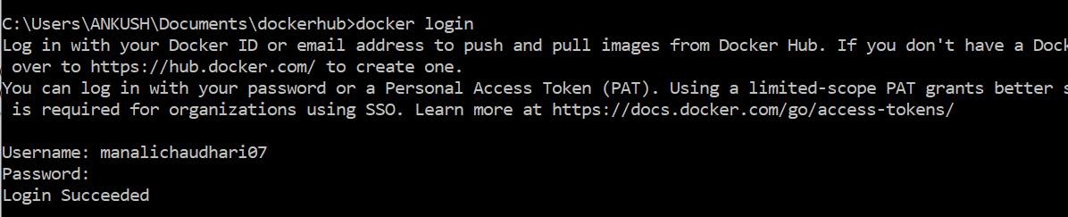

**3.Push your image into Docker hub as public repository.**

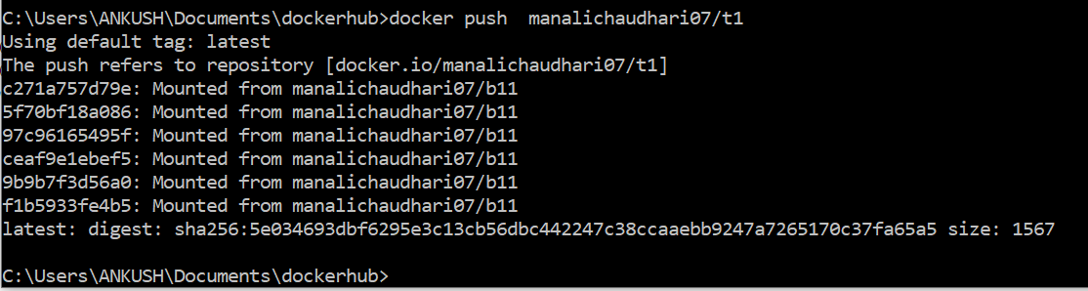

**4. Run the commands on Docker terminal**

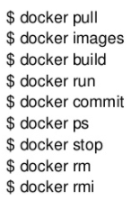

**docker pull**

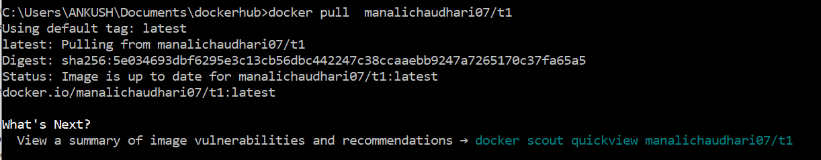

**docker images**

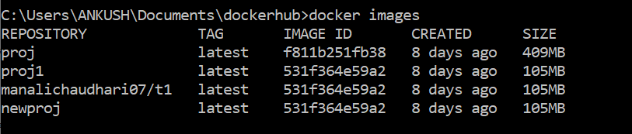

**docker build**

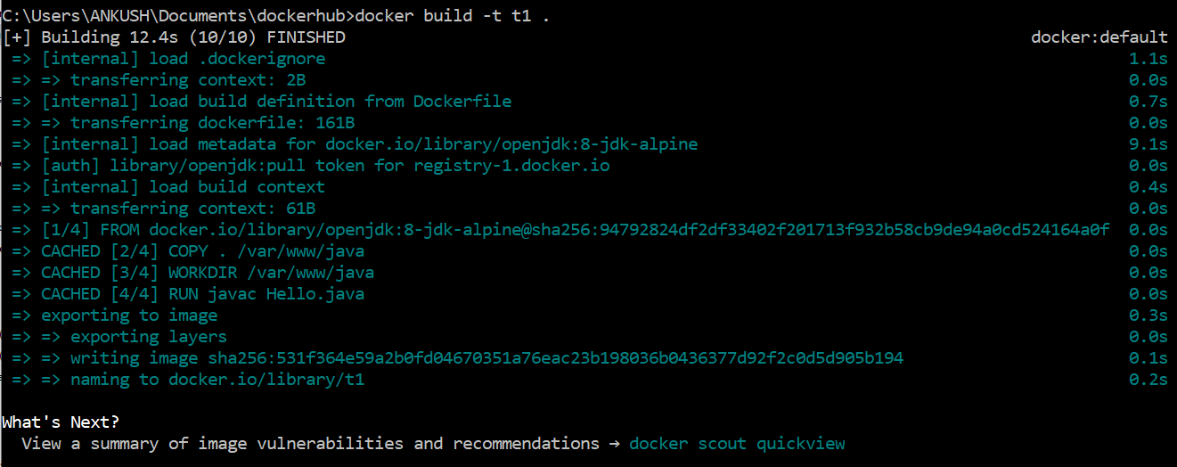

**docker run**

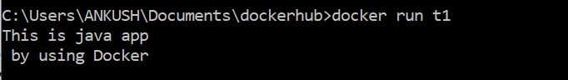

**docker ps**



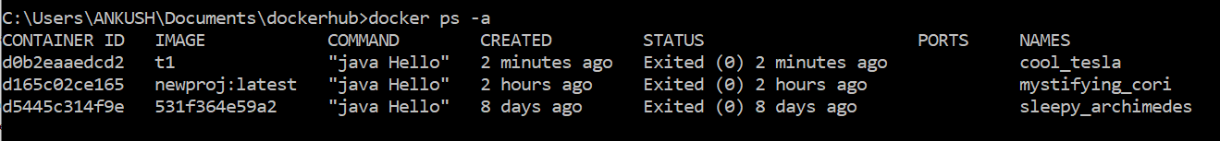

**docker stop**

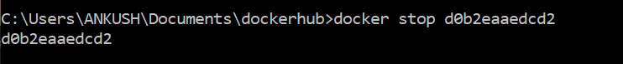

**docker rm**

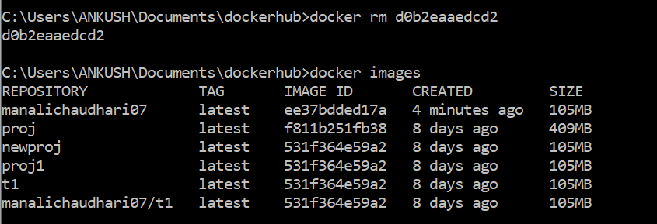

**docker rmi**

